**Screenshots:**

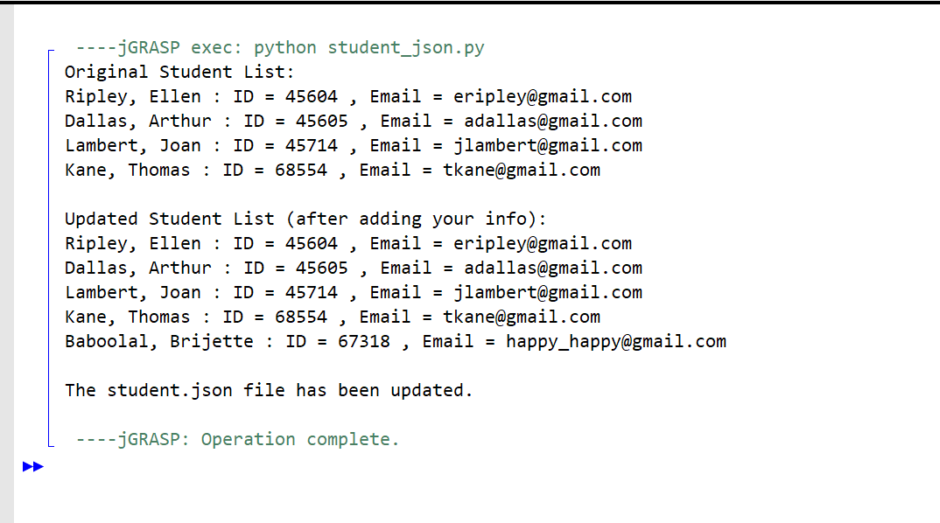

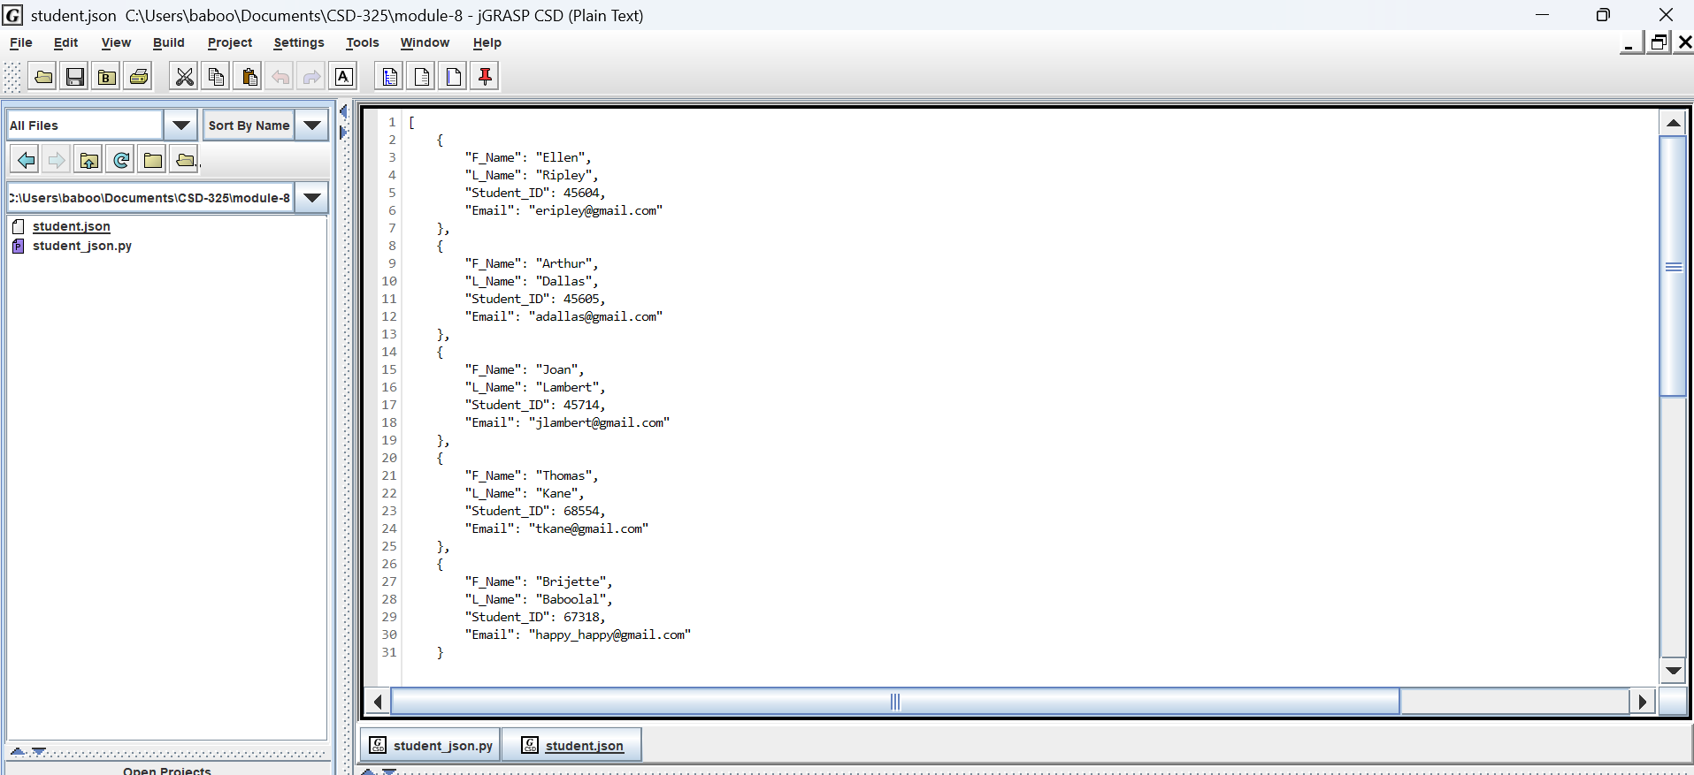

**Flowchart:**

End

Final print to user

Saving data to file

Output to user

Adding the student to the list

Creating a new student dictionary

Output to user

Reading data from the file

Start